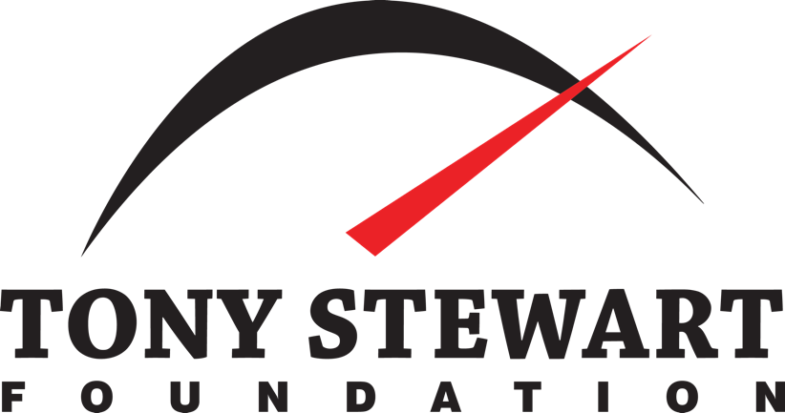

2021 Grant Application
Return Forms and Required Items by October 1, 2021 to:
Tony Stewart Foundation
438 Southpoint Circle Brownsburg, IN 46112-2203
erica@tonystewart.com
(317) 299-6066

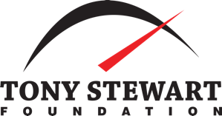
2021 Application with 2020 Funds Report Return form and Required Items by October 1, 2021
The Board of Directors has combined the 2021 Grant APPLICATION with the mandatory 2020 FUNDS REPORT. The combined information will be used to determine funding allocations. Additional materials may be submitted.

Organization Name ________________________________________________________________________
Our organization primarily serves: ___ Children ___ Animals ___ Both ___Drivers
MISSION STATEMENT: _____________________________________________________________________________________________________________________________________________________________________________________________________________________________________________________________________________________________________________________________________________________________________________________________________________________________________________________________
Street Address ____________________________________________________________________________ City ________________________________________________________ State ________ Zip _____________ Year Formed _________ EIN # ____________________ Main Phone No. (______) ______________________ Web URL _________________________________________________________________________________ Facebook _________________________________________________________________________________ Twitter __________________________________________________________________________________ Instagram ________________________________________________________________________________ Other ____________________________________________________________________________________
Submitter’s Name ___________________________________________ Title __________________________ Primary Phone No. (______) ______________________________________ Mobile ___ Home ___ Office___ Primary Email _____________________________________________________________________________
This completed form must be returned with: ___ IRS Letter of Determination.
Our organization’s geographical reach: ___ Local Community ___ Multiple Counties ___ Statewide ___ Multi-State ___ National

ORGANIZATION NAME: _____________________________________________
Organizational Budget & Funding. Information taken from our organization’s Form 990 filed for FY20_______.
____________ Line 12 / Total REVENUE
____________ Amount from Line 15 / Salaries, Benefits & Other Compensation ____________ Amount from Line 16b / Total Fundraising Expenses
____________ Amount from Line 18 / Total EXPENSES
Organizational Staffing. ____________Number of PAID full-time employees
____________Number of PAID part-time employees
____________Number of PAID contracted employees
____________Number of student interns, paid or unpaid
____________Number of full-time volunteers / more than 8 hours per week
____________Number of part-time volunteers / less than 8 hours per week or seasonally ____________Line 12 / Total REVENUE
____________Amount from Line 15 / Salaries, Benefits & Other Compensation Amount from Line 16b / Total ____________Fundraising Expenses
____________Amount from Line 18 / Total EXPENSES
- Chief Executive Officer for your organization
Name ____________________________________________________Title_____________________ Email Address ______________________________________Telephone(_____)_________________
- Fundraising (Development) Officer for your organization
Name ____________________________________________________Title_____________________ Email Address ______________________________________Telephone(_____)_________________
- Communications / Marketing Officer for your organization
Name ____________________________________________________Title_____________________ Email Address ______________________________________Telephone(_____)_________________
Briefly identify two (2) major programs or services currently offered by your organization. ____________________________________________________________________________________________________________________________________________________________________________________________________________________________________________________________________________________________________________________________________________________________________________________________________________________________________________________________________________________________________________________________________
ORGANIZATION NAME: _____________________________________________
Proposed Program/Service: _______________________________________________
Describe the proposed program/service for which you are seeking 2021 TSF Grant funding. _____________________________________________________________________________________________________________________________________________________________________________________________________________________________________________________________________________________________________________________________________________________________________________________________________________________________________________________________
Annual Cost of the Proposed Program/Service $ ________________ / ________ % of funding secured Duration of Program/Service ___ One-time program ____ Once per year ___ Continuous ___ Periodic
Is this program ____ Established ____ New ____ Proposed with Funding
Is the planning or implementation already underway? ___ Yes ____ No
How many children/families or animals are served within a one-year period through this program? ___________________________________________________________________________________________________________________________________________________________________________________________________________________________________________________________________________Identify benefits or impact beyond the specific program/service that engage the community or your donors. __________________________________________________________________________________________________________________________________________________________________________________ _________________________________________________________________________________________
Provide a brief statement about Unique Feature(s) setting it apart from similar programs or services offered by other organizations. ___________________________________________________________________________________________________________________________________________________________________________________________________________________________________________________________________________
Growth Opportunity, whether for the program itself or for the organization as a whole. __________________________________________________________________________________________________________________________________________________________________________________ _________________________________________________________________________________________
ORGANIZATION NAME: _____________________________________________

Income for the PROGRAM or SERVICE submitted for consideration of a TSF Grant.
$____________ Service or Admission Fees
$____________ Corporate Donations or Sponsorships
$____________ Individual Contributions
$____________ Special Event Fundraising
$____________ Foundation Grants (not TSF)
$____________ Internal Reallocation
$____________ Government Funding
$____________ Other: __________________________________________________________________ $____________ Total Expected Revenue for the Program or Service
$____________ SPECIFIC INTERNAL BUDGET ALLOCATION for the Program or Service $____________ SPECIFIC FUNDING REQUEST from the Tony Stewart Foundation - TSF %____________ PERCENTAGE of Total Program or Service Funding Requested from TSF

Our organization and its Board of Directors authorize submission of this funding request. Our tax-exempt status under IRS Section 501(c)(3) has not been revoked or modified. We understand that if selected to receive funding we must furnish a report showing how the funds were spent and that the funds are to be spent solely for the purpose for which the original grant is sought.

Executive Director: _______________________________________________________ Date: _____________ Board Chair or President: __________________________________________________ Date:_____________ Development Director: ____________________________________________________ Date: _____________

ORGANIZATION NAME: _____________________________________________
2020 GRANT FUNDS REPORT
Name of the 2020 Funded Program____________________________________________________________ Staff or Volunteer with Primary Responsibility for the Program
Name __________________________________________Title______________________________________ Email ____________________________________________________________________________________
2020 TSF Grant Awarded was: $___________________________
2020 Total Expenses for the Program were: $________________
Was the program fully funded for 2020? ____ Yes ____ No
If not, what internal reallocation or external adjustment was needed to make the program or service viable? __________________________________________________________________________________________________________________________________________________________________________________ __________________________________________________________________________________________________________________________________________________________________________________
Identify the funding resources specific to the program or service for which the 2019 TSF Grant was applied.
$____________ Service or Admission Fees
$____________ Corporate Donations or Sponsorships
$____________ Individual Contributions
$____________ Special Event Fundraising
$____________ Foundation Grants (not TSF)
$____________ Internal Reallocation
$____________ Government Funding
$____________ Other: __________________________________________________________________
Provide any narrative or statistics (including external documents) demonstrating that stated goals of the program or service were met. __________________________________________________________________________________________________________________________________________________________________________________ _________________________________________________________________________________________ _________________________________________________________________________________________ ___________________________________________________________________________________________________________________________________________________________________________________________________________________________________________________________________________ __________________________________________________________ _______________________________

